**User Persona**

[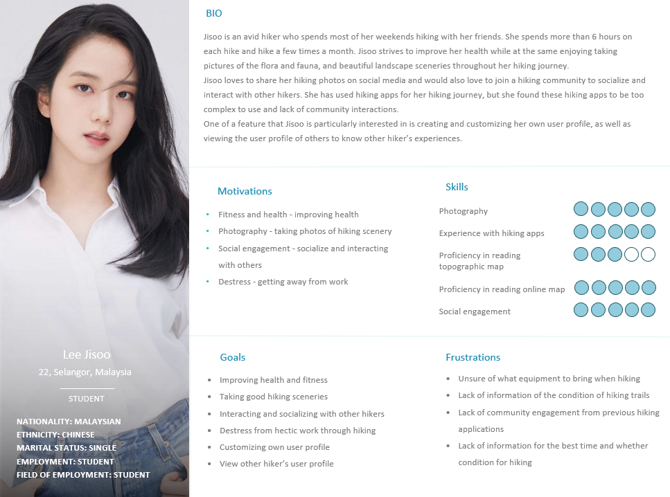](https://imgur.com/M6gpHDZ)

[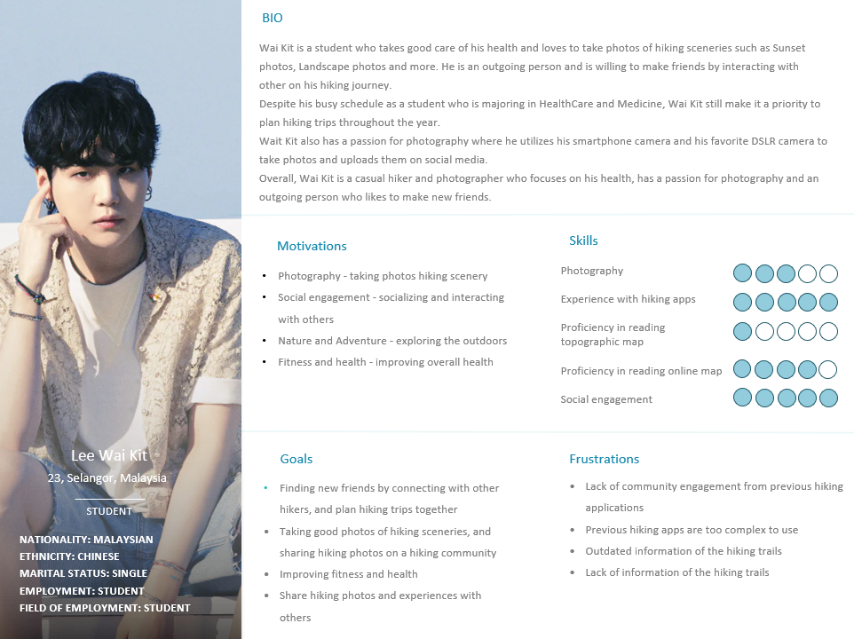](https://imgur.com/vshrXjE)

**User Stories**

| Priority | User Stories | Justification |
| --- | --- | --- |
| Must have | * As Wai Kit, I want to find updated informations about hiking trails so that I can plan my hiking journey accordingly | * Information based on the condition of the trails should be added and updated regularly to allow the users to be well prepared for any unexpected outcomes or dangers. For example, if the hiking trail condition is wet or unstable, the users should be pre-informed so that users can prepare special equipments or even avoid these hiking trails |
| Should have | * As Jisoo, I want to be able to find hiking communities so that I can socialise and interact with others that like hiking too. | * An implementation of a hiking community should be implemented to allow the users to be able to socialise and interact with others. The hiking community should be a more comfortable place for hikers to share their experiences or hiking photography with other hikers with similar interests as each other. |
| Could have | * As Wai Kit, I want to be able to add new friends in a hiking app so that I can plan hiking trips with them * As Jisoo, I want to be able to create a hiking user profile so that I can customise my user profile and express myself as well as viewing other people’s user profile * As Wai Kit, I want to be able to share my hiking photos in a community so that I can connect with other hikers and inspire other hikers. | * A feature of adding new friends could be added in order to keep in contact with those that they have recently interacted with, or usually interact with for much convenience in planning new hiking trips as well as encouraging interaction between hikers. * A feature regarding creating a user profile could be added in order for users to save their hiking experiences as well as expressing themselves in terms of their recent hiking activity. * A community feature that allows the users to share their hiking photos would be a great way for users to express their passion in hiking as well as hiking activities. |
| Won’t have |  |  |

**2 additional Requirements**

* Community feature to socialise with other hikers and photographers
  + A community feature in the hiking app where users can socialise with other hikers and hikers who love photography could be implemented. This is because based on the collected responses, users who have used a hiking app in the past have brought up a problem where the hiking app lacks community engagement to find hiking stories or information from others, and to socialise with others. From the collected data, about 62.5% of the respondents have also given a positive response to being interested in interacting with other hikers and photographers. Therefore, a hiking app that features a community function would be a great feature for the users to interact with other hikers and hikers who are interested in photography by creating new posts, threads or even sharing photos of their hiking experiences and journey
* Including a user profile feature in the hiking app
  + Based on the collected responses from our questionnaire, about 74% of the respondents are interested in having user profile customization options. These customizations would be a great way for users to share their hiking experiences by creating posts on their profile to share their hiking experience, adding a biography to introduce themselves to others as well as adding updates to their profile. This would be a great way for the users to express themselves based on their hiking experiences, as well as getting to know more about other hikers as well.

**Individual analysis**

After collecting the data based on the responses of the questionnaire, two user personas were created. These user personas were created based on analysing the responses collected to identify common patterns and trends that have occurred in the majority of respondents. The user stories derived from the user personas enables the developers to describe how the majority of the users might interact with the hiking app by considering the various needs and goals of the users. This approach helps ensure that the final product of the hiking app fulfils the needs of the target audience and provides a user experience that caters to the preferences of the users.

Jisoo is a 22 year old female student who was born and raised in Malaysia. She is an avid hiker who spends most of her weekends hiking with her friends, and she spends more than 6 hours on each hike, and hike a few times a month. Jisoo represents a group of hikers who strive to socialise and interact with other hikers. This is based on a group of respondents where about 36% of the respondents’ motivations in hiking is to socialise and interact with other hikers, and about 62.5% of the respondents gave a positive response into being interested in engaging with other hikers and photographers. Therefore a community feature could be implemented to allow the users to interact with other hikers and photographers with similar interests by sharing their hiking experiences as well as making new friends to plan hiking trips together. One of the main motivations of Jisoo is to create and customise her own user profile in order to express herself, share her hiking experiences on her profile as well as view other hikers’ profile to know more about their hiking experiences. This is inspired by the responses from the questionnaire where about 52% of the respondents gave a positive response to seeing a customisation feature in the hiking app. A user profile is a good way for users to get to know more about the personalities of other hikers as well as hiking experiences based on other hiker’s user profile, and therefore finding new friends that suits their personality as well.

Wai Kit is a 23 year old Chinese student who was also born and raised in Malaysia. He plans hiking trips throughout the year and takes good care of his health and loves to take photos of different hiking sceneries such as Sunset, Landscape photos and more. He is an outgoing person and is willing to make friends by interacting with others. Wai Kit’s biography was taken from the traits of the majority respondents where about 88% of the respondents fall in the age range of 18-25 years old, and about 89% of the respondents are Malaysian Chinese. One of Wai Kit’s goals and motivations in hiking is to utilise his smartphone camera and his favourite DSLR camera to take good photos of hiking sceneries throughout his hiking journey, and sharing them to a hiking community. This trait has been taken from a part of the respondents where about 48% of the respondents’ motivation in hiking is to take good hiking photos throughout his hiking journey, and 50% of those respondents who are engaging in community features often share their hiking photos on social media. One of Wai Kit’s frustrations about previous experiences on hiking apps is the lack of information, or outdated information on the hiking trails. This can be deduced from the responses of the questionnaire where 71% of the respondents responded that one of the challenges they have faced is not having enough information of the hiking trail, and therefore being too cautious on whether the hiking trail would be safe for them to explore.